**2 Man Transition Drill**

* 1 line on the baseline and 1 line on the right side line (starting under both baskets)
* “Rebounder” tosses it off the back board and rebounds at the highest point
* “Ball handler” gets to the side line and calls for outlet pass
* “Rebounder” out lets the ball and then runs the sideline
* “Ball handler” pushes the ball up the middle 1/3 of the court as the “rebounder” runs for a lay up
* “Ball handler” makes a scoring pass to the “rebounder”
* 2 Groups will be going simultaneously on both sides of the court in opposite directions

<https://basketballhq.com/2-man-outlet-basketball-drill>

Keys:

* Run wide for lay ups
* Ball Handler call for outlet pass
* Ball handler jump stop to avoid charges

**Laker Fast Break Drill**

* 3 lines on baseline (2 corners and middle)
* Ball starts in the middle, all 3 guys run their lane, ball passed to the left side (right side for left hand layup)
* Guy who catches the ball on the left sideline passes the ball back to the guy in the middle.
* Guy in the middle then passes the ball to the guy running the right sideline for a lay up
* **Ball CANNOT hit the floor**
* Middle man touches the baseline corner and then runs the left sideline
* Person who shot the first lay up then runs the right sideline
* The person who initially ran the left sideline get the rebound and throws the first pass to the right.
* The person running the right sideline passes the ball back to the middle man who then throws a scoring pass to the person running the left sideline for a left hand layup

<https://www.youtube.com/watch?v=tToyIDxSdN0>

Keys:

* First pass always goes to the same sideline
* Communicate at all times
* Sprint the lanes

**2v2 Get Back Drill (Continuous Transition drill)**

* 2 players start on offense with the ball while 2 players defend
* Offense tries to score **ONLY 1 SHOT**
* After the shot (make or miss) the 2 offensive players must sprint back on defense
* Players not on the court line up at the “X’s”
* The defenders outlet the ball to the next 2 guys coming on from on the sideline (new offense)
  + Old defenders get in back of a line on sideline
* The new offense pushes the ball and tries to score
* Make or miss the offensive guys get back on D
* Defenders outlet the ball to the new guys coming on from the sideline

<https://www.sportplan.net/drills/Basketball/2-v-2/2v2-Transition-Continuous-game-basketballm0056.jsp?onMobile>

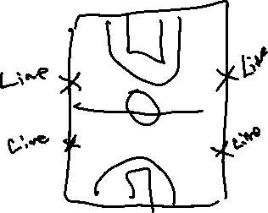

*Video shows the drill done in a different way (without guys waiting

on the sideline)

Teaching Points:

* Def- One person must stop the ball. Second person is in help
* Def- Play from the inside out
* Off- Attack until someone stops you. Stay wide for good spacing

**4 on 4 Transition Drill**

* 4 people lined up across the baseline
* 4 people lined up across the foul line across from the baseline guys

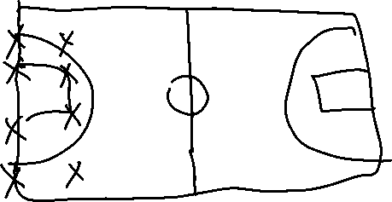

* Coach passes the ball to one of the guys on the baseline
* As soon as the offensive team (baseline guys) gets the ball they start a fast break attack
* The defender who is across from the person who catches the ball must sprint and touch the baseline (giving the offense a 4v3 advantage)
* The defender who touched the baseline sprints back trying to get back into the play

Option 1:

* Stop and have everyone come back down and do it again (creating and offensive advantage every time)

<https://www.youtube.com/watch?v=uI1e1XhlRxA>

Option 2:

* Have the 4 defensive guys come back down in transition on make or miss from original offense and have original offense guard them.

<https://www.youtube.com/watch?v=0tt_u1RV4wA>

Teaching Points:

* Def- One person must stop the ball. Other defenders are in help
* Def- Play from the inside out
* Off- Attack until someone stops you. Stay wide for good spacing

**Man to Man run and jump Press**

* Match up man to man full court
* 1 Person guarding the ball trying to force the pass into the nearside corner, other defenders forcing guards to corners

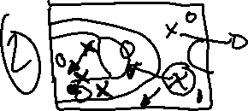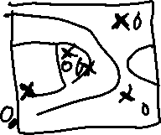

* When ball is passed in the defender guarding the in bounder follows the ball and traps it right away (Diagram 2)
* The weakside defender rotates to steal reversal pass back to in bounder. (diagram 2)
* The “interceptor” (circled defender) reads the ball-handlers shoulders and is anticipating the pass out of the trap like a safety in football. (diagram 2)
* The last defender is the rim protector and is responsible for being the last line of defense
* If the trap is unsuccessful defenders must sprint back and get back into ½ court defense

